**Our services**

**Compliance Service**

You may need to make annual data submissions declaring the amount and type of packaging, WEEE, or batteries your business handled.

Gathering and compiling data is complex. You also need to know what you are obligated to report and ensure its accuracy. The more data that’s involved, the more difficult and time consuming this challenge becomes.

Our compliance expert team will lead you through the process, ensuring your packaging data is as accurate as possible and that you remain compliant. For total peace of mind, we check your data with a fine-tooth comb before submission.

Our knowledge of the packaging market means we always get the best value recovery and recycling evidence for you.

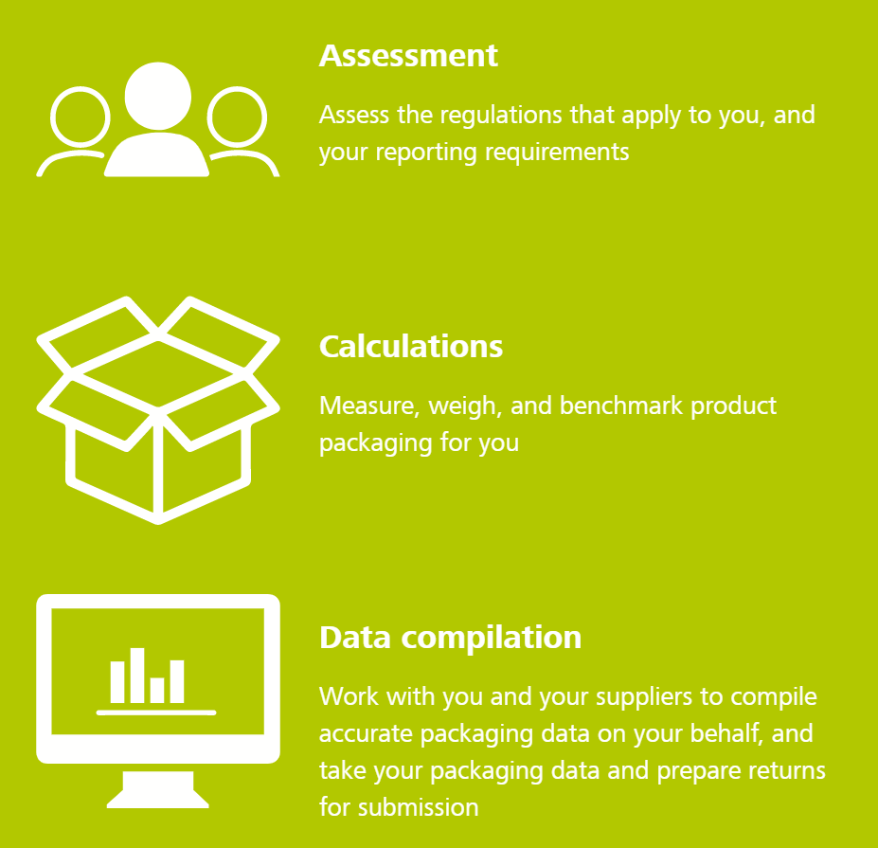

**Waste Consultancy**

Our Team has over 30 years of industry knowledge.

Waste companies don't want you know the value of your recyclables so they can charge for expensive bins and skips that are unnecessary.

Commercial Clients often tell our recycling experts, that their waste provider wont advise on ways to recycle more. Why is that case, you ask? Simply, it because waste companies have a conflict of interest. They won't advise on savings that you can make that will hurt their profits.

At **xxx**, as we are a Recycler and not a waste company, we have no such conflict. Our team is there to help you save on your waste. It is what we do.

***How are we able to do this?***

Our recycling experts undertake detailed site audits to assess, advise and recommend which materials can be removed from the general waste stream and sold to us as a recyclable, therefore creating a dual saving and savings you lots of money!

***Can xxx help with staff training?***

We certainly can. In most instances, once we install our best practice recycling systems, it is hassle free for staff members to segregate recyclables easily and the process works very well.

***What savings can we expect to make?***

The savings that can be made can vary from company to company dependant on size, volume and type of recyclables.

**WEEE**

WEEE (Waste Electrical and Electronic Equipment) regulations can be complex. Changing policies means the rules can vary annually, making it difficult to confidently calculate what you must pay. If your company is expanding across multiple European territories, these challenges multiply.

***How xxx makes it easy for your business, and add extra value along the way.***

We can assist at every stage in the disposal of WEEE and handle all the complexities, making things as simple as possible. Our solutions help you meet or surpass national standards and provide the best value for your business needs.

Using our experienced operations team and pan-European network of licensed waste carriers and treatment operators, **xxx** can arrange for the collection and treatment of WEEE from member sites.

We can provide bespoke take-back solutions and other waste services, and our product take-back offer also includes specialist services, such as secure destruction, if required.

